Important Notes on Replacement of New Supplier’s TP Screen on MaxiSys Tablets

- Part Number of new TP screen Involved

501003930 MS906
501003932 MS906BT
501004169 MS908
501003923 MS908S

Note: The above new TP screen is provided by a new supplier, which will be used for TP replacement of the above models.

- Preparations:

- Update operating system to the latest version first

E.g. Maxisys 906 V03.46.00, Maxisys906BT V03.31.00 , MY908 V03.41.00

If the MaxiSys was out of update period, please use reflashing program(sent via Wetransfer) to update it to the free version.

- Remove Resistance

- Remove R289 Resistance for MY908

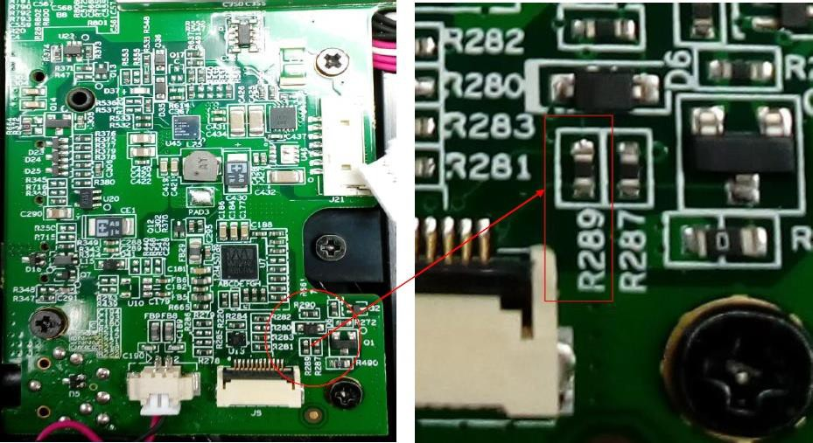

- Remove R375 Resistance for MY906/MY906BT

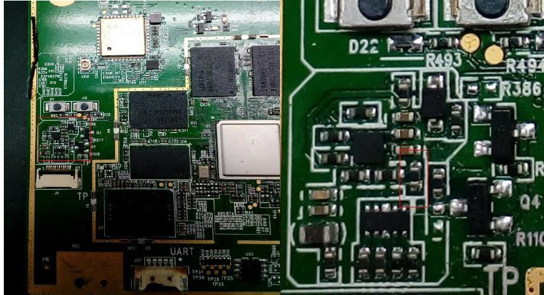

- Remove specific buttons for MY906,MY906BT,MY906TS

- 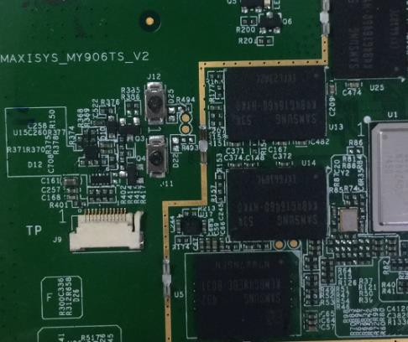Remove J11, J12 buttons(as showed below) for MY06BT, MY906TS

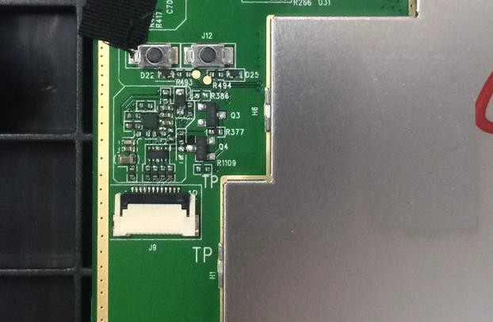2. Remove J11, J12 buttons (as showed below) for MY906

- Pasting way of TP for MY906,MY906BT,MY906TS

TP plate should be pasted parallelly with the magnesium alloy stent.
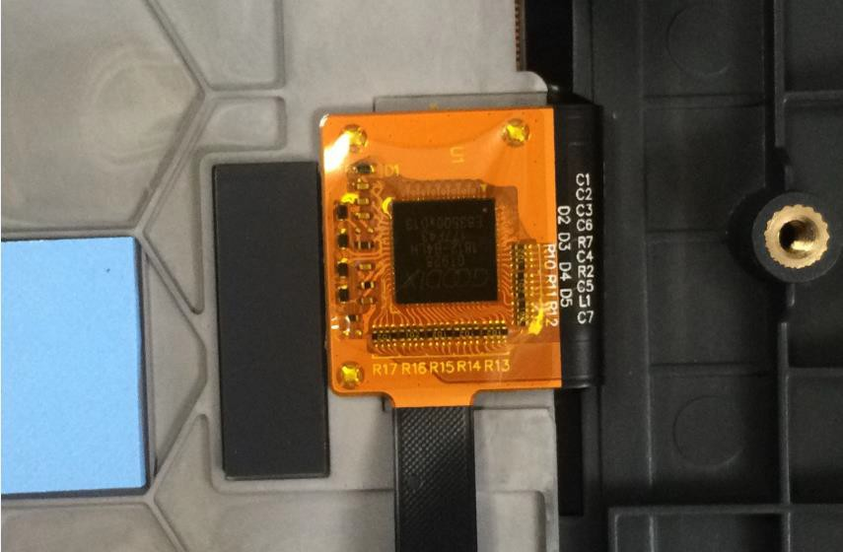

TP钢片与

镁合金支架

平齐粘贴

