FLY OBD Terminator Support car List
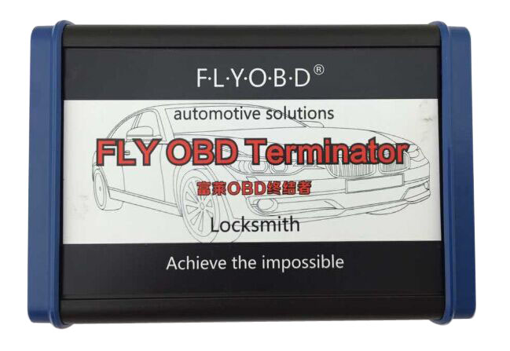
1. ALL Honda;
2. ALL Ford;
3. ALL Mazda;
4. ALL LandRover;
5. ALL Jaguar ;
6. ALL Toyota and Lexus ;
7. A4/A5/Q5 2007+ Generation 5 Immobilizer;（
1.Read BCM2 Immobilizer Data By OBDII;
2.Generate dealers keys and key learning;
3.Open/close Immobilizer Horn;
4.Recover Emergency data(Data recovery and wake up in the process of reading immobilizer data failure cases);
5.Check the new PCF7945AC (HitagExt VAG);
6.Load decode file (Can generate dealer key and learning key);
7.Load PFLASH and DFLASH file (Can generate dealer key and learning key);
）;
8. A6/A7/A8/VW Touareg Generation 5 Immobilizer;（
1.Read BCM2 Immobilizer Data By OBDII;
2.Generate dealers keys and key learning;
3.Open/close Immobilizer Horn;
4.Recover Emergency data(Data recovery and wake up in the process of reading immobilizer data failure cases);
5.Check the new PCF7945AC (HitagExt VAG);
6.Load decode file (Can generate dealer key and learning key);
）;
9. PIN Calculator Functions:（
1.Nissan 20-digit and 5-digit PIN Calculator;
2.JLR SDD Coded Access Password Calculator;
3.Ford and Mazda Incode Calculator(Include 6-digit,12-digit or 16-digit Outcode);
4.Honda Password Calculator(Include First Password, Second Password, HIM Unlock Password and 4-digit PCM Password
);
10. Reset of Toyota/Lexus/Subaru Smart Keys（
1.Reset of Toyota/Lexus/Subaru Smart Keys 40,80,128 bit;
）;
11. VAG Generation 4 Immobilizer，NEC Dashboard 95320;（
1.Automatically recognize VAG Generation 4 NEC 95320 Dashboard;
2.Add VAG Generation 4 NEC 95320 Dashboard key directly;
3.Read VAG Generation 4 NEC 95320 Dashboard Immobilizer data;
4.Modify VAG Generation 4 NEC 95320 Dashboard Immobilizer data;
5.Read and save VAG Generation 4 NEC 95320 Dashboard configuration data;
）；
12. VAG Generation 4 Immobilizer, NEC Dashboard 24C32;
13. JLR SDD Coded Access Password for Locked Functions;
1.Jaguar:
CCF EDITOR
ODO APP (X150)
ODO APP (X250)
ODO APP (X351)
SOFTWARE DOWNLOAD
VID BLOCK EDITOR
VIN BYPASS
RECOVER KEYS (X351)
; 2.Land Rover:
CCF EDITOR
ODO APP (L316))
ERASE KEYS (L322)
ODO APP (L322)
RECOVER KEYS (L322)
OPTION 8
SOFTWARE DOWNLOAD
VEHICLE UPDATE (Only Taiwan models)

