Test Platform Cable User Manual
1. Wiring Connection
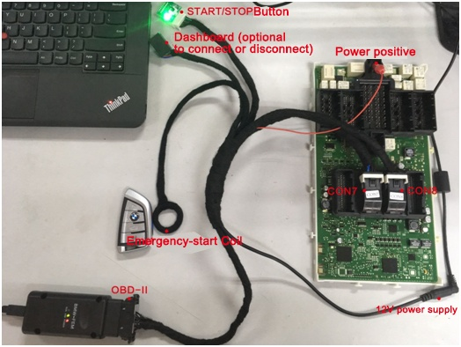
Pic. 1 Cables & adapters wiring connection diagram
二、钥匙放置
2. Key Position
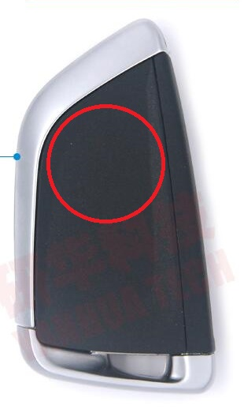
Pic. 2 Emergency-Start coil position
Put the key marked with red (see above pic.2) on the coil.
三、START/STOP按键操作
3. START/STOP button operation
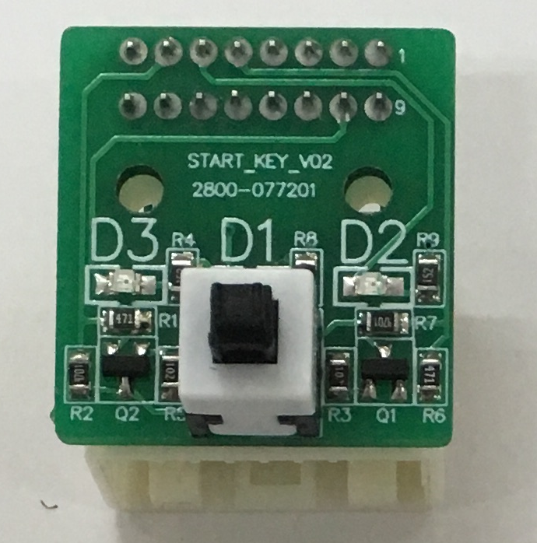
D1为START/STOP按键状态指示灯, 接上电源, 指示灯点亮。
D2为发动机自动启停装置( MSA ) 状态指示灯。默认熄灭。
D3为电门状态指示灯, 可代替仪表显示电门状态。电门打开时, 指示灯亮; 电门关闭时, 指示灯灭。
D1: START/STOP button’s indicator- light on when the power supply is connected
D2: Automatic stop and start function (MSA) indicator- default status: light off
D3: Engine fire shutoff switch’s indicator (to replace the dashboard and display the status of the engine fire shutoff switch)- light on when the switch is turned on and light off when the engine is turned off

打开电门操作:
将工作钥匙放在线圈上, 按下按键, 电门状态指示灯 ( D3 ) 点亮。若指示灯不亮, 可稍等3~5秒再按一次。
How to turn on the engine fire shutoff switch:
Put the working key on the coil;
Press the button;
Engine fire shutoff switch indicator (D3) lights on;
(If the indicator fails to light on, wait for 3-5 seconds and press it again)
关闭电门操作:
连按三次按键, 指示灯( D3 )熄灭, 则电门关闭。
How to turn off the engine fire shutoff switch:
Press it continuously for 3 times;
Engine fire shutoff switch indicator (D3) lights off- engine fire shutoff switch is turned off

