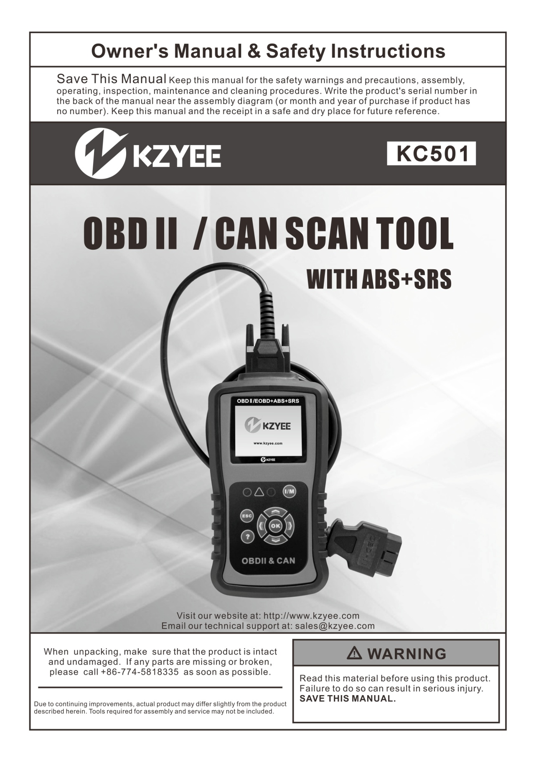

Table of Contents

Safety...............................................1
Specifications .................................2
Overview.........................................2
Definitions......................................3
Control Modules ...........................3
I/M Monitors..................................4
Diagnostic Test Modes .................5
Diagnostic Trouble Code .............6
Setup - Before Use: ......................7
Operating Instructions ...............9
Connect Scan Tool .....................9
Setup ..........................................10
I/M Readiness Quick-Check ......14
Diagnostic Test Modes ...............15
Read Trouble Codes ..................16
DTC Lookup ..............................17
Erase Codes .............................18
View Live PID Data ...................19

Record Live PID Data..................... 21
Playback Live PID Data.................. 24
View Freeze Frame Data................ 25
I/M Readiness................................. 25
02 Monitor Test ............................... 26
On-Board Monitor Test ................... 27
Component Test ............................. 28
Vehicle Information ......................... 29
Modules Present............................. 30
ABS+SRS Testing........................... 31
Review Data ................................... 32
Ready Test...................................... 32
Print Data........................................ 33
Install/Update Software .................. 33
About . ................................................34
Maintenance..................................... 35
Troubleshooting .............................. 36
Parts List ............................................37

R WARNING SYMBOLS AND DEFINITIONS
This is the safety alert symbol. It is used to alert you to potential personal injury hazards. Obey all safety messages that follow this symbol to avoid possible injury or death. Indicates a hazardous situation which, if not avoided,
will result in death or serious injury.
Indicates a hazardous situation which, if not avoided, could result in death or serious injury.
Indicates a hazardous situation which, if not avoided, could result in minor or moderate injury.
Addresses practices not related to personal injury.

Important Safety Information

To prevent personal injury or damage to vehicles and/or the Scan Tool, read this instruction manual first and observe the following safety precautions, at a minimum, whenever working on a vehicle:

1. Always perform automotive testing in a safe environment.

2. Wear safety eye protection.

3. Keep clothing, hair, hands, tools, test equipment, etc. away from all moving or hot engine parts.

4. Operate the vehicle in a well ventilated work area. Exhaust gases are poisonous.

5. Put blocks in front of the drive wheels and never leave the vehicle unattended while running tests.

6. Use extreme caution when working around the ignition coil, distributor cap, ignition wires and spark plugs. These components create hazardous voltages when the engine is running.

7. Put the transmission in PARK (for automatic transmission) or NEUTRAL (for manual transmission) and make sure the parking brake is engaged.

8. Keep a fire extinguisher suitable for gasoline/ chemical/ electrical fires nearby.

9. Don't connect or disconnect any test equipment while the ignition is on or the engine is running.

- Keep the Scan Tool dry, clean, free from oil, water or grease. Use a mild detergent on a clean cloth to clean the outside of the Scan Tool, when necessary.

Service

There are no user serviceable parts. Scan Tool service must be performed only by qualified repair personnel.

Specifications

Display Screen TFT Color (320 x 240) Operating Temperature 32°F to 140°F
Storage Temperature -4°F to 158°F
Power 8V to 18V power provided by vehicle battery

Overview

OBD II On-Board Diagnostics

The first generation of On-Board Diagnostics (called OBDI) was developed by the California Air Resources Board (ARB) and implemented in 1988 to monitor some of the emission control components on vehicles. As technology evolved and the desire to improve the On-Board Diagnostic system increased, a new generation of On-Board Diagnostic system was developed. This second generation of On-Board Diagnostic regulations is called "OBD II".

The OBD II system is designed to monitor emission control systems and key engine components by performing either continuous or periodic tests of specific components and vehicle conditions.

Vehicle Coverage

This Scan Tool is designed to work with all OBD II compliant vehicles, including those equipped with a CAN bus.
OBD II was installed in some 1994 and
1995 model year gasoline vehicles.

When a problem is detected, the OBD II system turns on a warning lamp (MIL) on the vehicle instrument panel to alert the driver typically by the phrase of “Check Engine” or “Service Engine Soon”.

The system will also store important information about the detected malfunction so that a technician can accurately find and fix the problem. Here are three examples:

1. Whether the Malfunction Indicator Light (MIL) is commanded 'on' or 'off';

2. Which, if any, Diagnostic Trouble Codes (DTCs) are stored;

3. Readiness Monitor status.

To verify if a 1994 or 1995 vehicle is OBD II compliant, check the Vehicle Emissions Control Information label, which is located in the engine compartment.

Definitions

• EOBD: European On-Board
Diagnostics
Essentially the same as OBD II, with the same Data Link Connector and Communication Protocols.
• Communication Protocol: Allows different systems and sensors in a vehicle to communicate.
There are currently five Protocols:
CAN Bus J1850 VPW ISO 9141-2
J1850 PWM
ISO 14230 KWP
• CAN: Controller Area Network Message-based Communication Protocol serial bus.
• CAN Vehicle
2008 and newer.
• Pre-CAN Vehicle
2007 and older.
• DLC: Data Link Connector
The 16-cavity connector on the vehicle that allows communication between the computer system and the Scan Tool.

Control Modules

• Drive Cycle
A set of driving procedures that, when met, provide the Enabling Criteria for the I/M Monitors to run and complete their diagnostic tests.
• Enabling Criteria
Operating conditions that must occur during a Drive Cycle to cause the I/M Monitors to run and complete their diagnostic tests.
• MIL: Malfunction Indicator Lamp The vehicle’s “Check Engine” warning light that activates
when a DTC is stored.
• DTC: Diagnostic Trouble Code A code stored in the computer system’s memory, which helps to identify the fault condition that is causing the MIL to activate.
• Freeze Frame Data Operating conditions that are stored when a DTC is stored.
• PID - Parameter Identification Data
Data returned by the vehicle’s
Control Modules to the Scan Tool.

Control Modules are individual computers that operate and monitor different systems in the vehicle. Control Modules vary depending on manufacturer.
ID codes are assigned to each Control Module, which are defined by the vehicle’s Communication Protocol.
For example, a vehicle may use ID code $7E8 for the PCM and $7E9 for the TCM.

Control Module Control Module Definition
PCM/ECU Powertrain Control Module/Engine Control Unit
TCM Transmission Control Module
Figure 1: Common Control Modules

I/M Monitors
Inspection and Maintenance diagnostic tests that the Control Modules perform on specific sub-systems of the vehicle.

There are two types of Monitors:
• Continuous: Monitors that perform tests all the time while the engine is running.

Gasoline Engine Monitors
Continuous
MIS - Misfire
FUEL - Fuel System
CCM - Comprehensive Components
• Non-Continuous: Monitors that require specific operating conditions to be met during a Drive Cycle in order for the Monitors to run their testing sequences.
Note: Not all Monitors are supported by all vehicles.

Non-Continuous
CAT - Catalyst
HCAT - Heated Catalyst EVAP - Evaporative System AIR - Secondary Air System O2S - Oxygen Sensors
HRT - Oxygen Sensor Heater
EGR - EGR System

Diesel Engine Monitors

Continuous
MIS - Misfire
FUEL - Fuel System
CCM - Comprehensive Components

Non-Continuous
HCCAT - NMHC Catalyst NCAT - NOx Aftertreatment BP - Boost Pressure System EGS - Exhaust Gas Sensor PM - PM Filter
EGR - EGR System

Diagnostic Test Modes

Diagnostic Test Modes as described in the latest OBD II standard SAE J1979.

Note: Not all Modes are supported by all vehicles.

Mode $01 – Identifies the Powertrain information and shows current data available to the Scan Tool. This data includes: DTC set, status of on-board tests, and vehicle data such as engine RPM, temperatures, ignition advance, speed, air flow rates, and closed loop status for fuel system.
Mode $02 – Displays Freeze Frame Data. Same data as in mode 1, but it was captured and stored when a malfunction occurred and a DTC was set. Some of the PIDs for Mode $01 are not implemented in this mode.

Mode $03 – Displays the type of Powertrain or emission related DTCs stored by a 5 digit code identifying the faults. There may be more than one response message if there are more trouble codes than will fit in the data bytes of the response message, or if there are more than one ECU computer responding.

Mode $04 – Used to clear DTCs and Freeze Frame Data. This clears all DTCs that may be set including freeze frame data and Readiness Monitors.

Mode $05 – Oxygen Sensor Test Results. This mode displays the oxygen sensor monitor screen and the test results gathered about the oxygen sensor.

Mode $06 – Non-Continuously Monitored Systems test results. There are typically a minimum value, a maximum value, and a current value for each non-continuous monitor. This data is optional, and it is defined by a given vehicle maker if it's used.

Mode $07 – Request for DTCs (pending) from Continuously Monitored Systems after a single driving cycle has been performed to determine if repair has fixed a problem. This is used by service technicians to verify repair was performed properly and after clearing DTCs.

Mode $08 – This special Control Mode requests control of the on-board system, test, or component bi-directionally (where applicable). This mode is manufacturer specific.

Mode $09 – Reports vehicle information. This information includes vehicle VIN number and calibration information stored in the vehicle ECUs.

Mode $0A – Request Emission-Related Diagnostic Trouble Codes with Permanent Status. This mode is required for all emissions-related DTCs. The presence of permanent DTCs at an inspection without the MIL illuminated is an indication that a proper repair was not verified by the on-board monitoring system.

Diagnostic Trouble Code

A five digit alphanumeric identifier for a fault condition identified by the OBD II system. There are three types of DTCs:

1. Pending - When a fault condition is identified during a Drive Cycle, but does not meet enough criteria to activate the MIL.
If the fault condition occurs during two consecutive Drive Cycles, it will turn into a Stored DTC and the MIL will activate.
2. Stored - A DTC is stored when a fault condition has occurred that meets enough criteria to activate the MIL.
3. Permanent - A stored DTC that can only be cleared by the OBD II system, after repairs are made, and a set number of Driving Cycles have been completed.

Example: P0212 - Injector Circuit / Open Cylinder 12

Systems
B - Body
C - Chassis
P - Powertrain
U - Network
Code Types*
0 - Generic
1 - Manufacturer Specific
2 - Generic Powertrain/Manufacturer Specific
3 - Generic Powertrain/Manufacturer Specific

Sub-Systems
1 - Fuel and Air Metering
2 - Fuel and Air Metering
(injector circuit malfunction only)
3 - Ignition Malfunction or Engine Misfire
4 - Auxiliary Emission Controls
5 - Vehicle Speed or Idle Controls
6 - Computer Output Circuits
7 - Transmission Controls
8 - Transmission Controls

12 - Cylinder 12

P 0 2 1 2

*The Scan Tool supports the following Code Types:

Generic (SAE): B0, B3
C0, C3
P0, P2, P34-P39
U0, U3
Manufacturer Specific: B1, B2
C1, C2
P1, P30-P33
U1, U2

Figure 2

Setup - Before Use:

Read the ENTIRE IMPORTANT SAFETY INFORMATION section at the beginning of this document including all text under subheadings therein before set up or use.

Functions

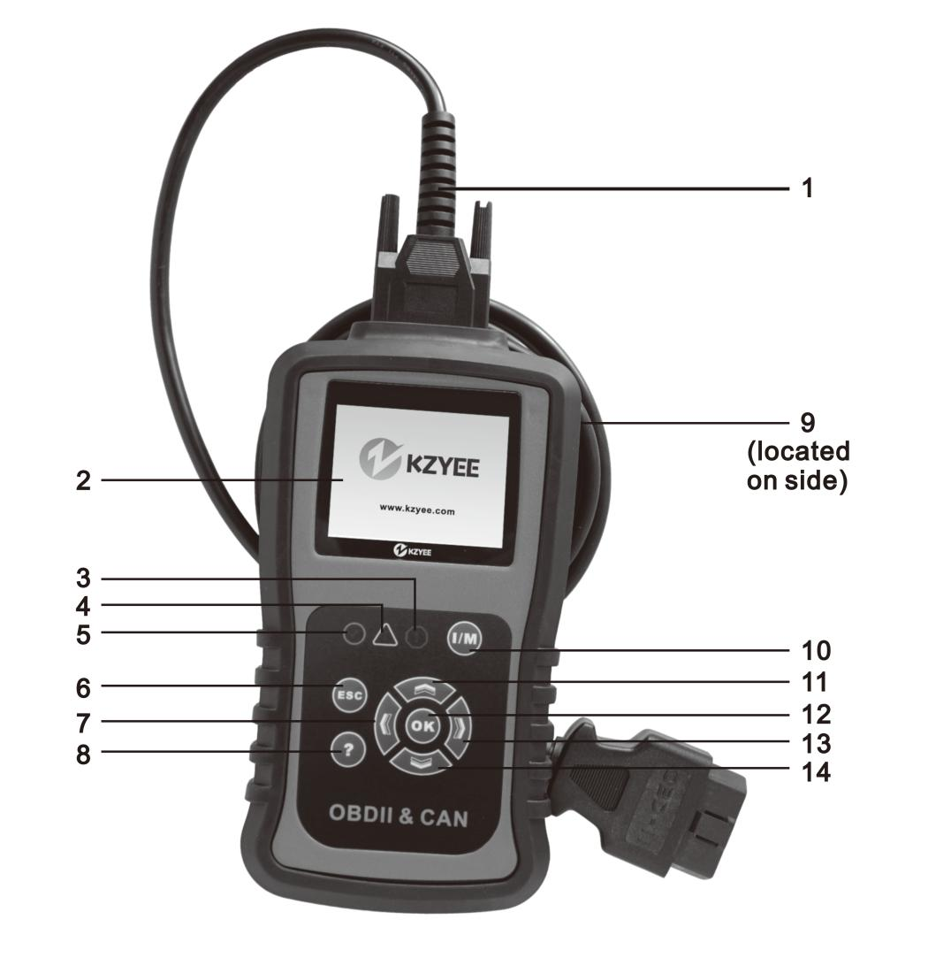

Figure 3

1. OBD II Cable
Connects the Scan Tool to the vehicle’s DLC.

2. LCD Screen
3. Red LED !
Indicates there is a problem in one or more of the vehicle's systems. The RED LED is also used to show that DTCs are present. DTCs are shown on the Scan Tool's display. In this case, the MIL on the vehicle's instrument panel will light steady on.
4. Yellow LED !
Indicates there is a possible problem. A “Pending” DTC is present and/or some of the vehicle's emission monitors have not run their diagnostic testing.
5. Green LED √
Indicates that engine systems are running normally (The number of monitors on the vehicle which are active and performing their diagnostic testing is in the allowed limit, and no DTCs are present).

6. Cancel/Go Back
Cancels a selection from a menu or returns to the previous screen.

7. Left Button
Moves to previous screen if information covers more than one screen.

8. Help Button ?
View detailed information, if available.

9. USB Connector
Connects the Scan Tool to a PC for updating software and printing.

10. I/M Button
Quick-checks emissions test readiness and Drive Cycle verification.
11. Up Button
Moves up through menu and submenu items in menu mode. When more than one screen of data is retrieved, moves up through the current screen to the previous screens for additional data.

12. Select Button OK
Confirms a selection.

13. Right Button
Moves to next screen if information covers more than one screen.

14. Down Button
Moves down through menu and submenu items in menu mode. When more than one screen of data is retrieved, moves down through the current screen to next screens for additional data.

Operating Instructions

Read the ENTIRE IMPORTANT SAFETY INFORMATION section at the beginning of this document including all text under subheadings therein before set up or use of this product.

TO PREVENT SERIOUS INJURY AND DEATH:
Exhaust gases are poisonous. Operate the vehicle in a well ventilated work area. Wear ANSI-approved safety goggles during use.

Connect Scan Tool

CAUTION: Do not connect or disconnect the Scan Tool while the ignition
is on or the engine is running.
Note: The Scan Tool is powered by the vehicle’s battery.
1. Turn the engine and ignition OFF.
2. Connect the OBD II Cable to the Scan Tool.
3. Connect the other end of the
Cable to the 16-cavity DLC.
The DLC is normally located under the dashboard on the driver’s
side. (Refer to vehicle’s owner’s manual for location of DLC.)

4. Turn the vehicle’s ignition ON
with the engine OFF.
Note: If Linking Error! message displays:
• Press the ESC button
• Verify the ignition is ON
• Verify the vehicle is OBD II compliant
5. If the message does not go away, have the Scan Tool inspected
by a qualified technician.
Note: To quick-check Emissions
Test Readiness, see page 17.
Note: To read Diagnostic Trouble
Codes, see page 19.

Figure 4: DLC

Setup

From the Main Menu, use the Up/ Down/ left/ Right button to select Setup, then press OK. Note: Setup is not required to operate the Scan Tool.
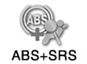
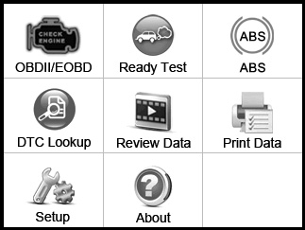

System Setup 1/7

Language

Main Menu
Configure Monitors ? Unit of Measure
Key Beep Set Status Beep Set Tool Self-test Update Mode

Figure 5

Set Language

1. From System Setup, use the Up/ Down button to select Language, then press
OK.
2. Select desired language, then press OK.

o English
o Español

Language 1/3

?

o Français

Figure 6

Configure Monitors

Note: Configuring the Monitors is
not required to operate the Scan Tool.
BEFORE CONFIGURING MONITORS:
• Run “I/M Readiness Quick-Check” on page 17 to determine which Monitors are not supported on the vehicle.
• Refer to EPA guidelines for acceptable incomplete monitor limits.
1. From System Setup, use the Up/ Down button to select Configure Monitors,
then press OK.

Configure Monitors 1/4

Spark IGN Required Mon. Compression IGN Required Mon. Allowed INC Monitors ?
Reset Factory Default

Figure 7
2. Select a configuration, then press OK.
a. Spark IGN Required Mon.
For gasoline engines.
b. Compression IGN Required Mon.
For diesel engines.
c. Allowed INC Monitors to Set how many incomplete Monitors are acceptable.
d. Reset Factory Default

3. Custom Data Set screen shows which buttons can be used to configure the monitors. Press any button to move to the next screen.

……………Custom Data Set……… …..

[ ] – Select/Deselect
[ ] – Select/Deselect all
[OK] – Confirm
[ESC] – Cancel

Press any key to con.

Figure 8
4. For Spark IGN Required Mon. and Compression IGN Required Mon., deselect Monitors that are not supported on the vehicle, see “I/M Readiness Quick-Check” on page 17.

………Sppark IGN Monitors 1/10
√ MIS
√ FUEL
CCM ?
√ CAT HCAT
√ EVAP

Figure 9
5. For Allowed INC (incomplete) Monitors, select the number of incomplete Monitors allowed. Refer to EPA guidelines for acceptable incomplete monitor limits.

………Alllowed INC Monitors 1/4
0
1
2 ?
3

Figure 10

Unit of Measure

1. From System Setup, use the Up/ Down button to select Unit of
Measure, then press OK

Unit of Measure

1/2

2. Select English or Metric,
then press OK.
o English

o Metric ?

Figure 11

Key Beep Set - Control Sound When Buttons are Pressed

1. From System Setup, use the Up/ Down button to select
Key Beep Set, then press OK.

Key Beep Set

1/2

2. Select Beep ON or Beep OFF,
then press OK.
o Beep ON

o Beep OFF ?

Figure 12

Status Beep Set - Control Notification Sounds

1. From System Setup, use the Up/ Down button to select Status
Beep Set, then press OK.

Status Beep Set

1/2

2. Select Beep ON or Beep OFF,
then press OK.
o Beep ON

o Beep OFF ?

Figure 13

Tool Self-test

From System Setup, select Tool Self-test, then press OK.

Display Test

1. From Tool Self-test, use the Up/ Down button to select
Display Test, then press OK.

Tool Self-test 1/3

2. To verify that the LCD screen is functioning properly, a color test will run.
3. Press ESC to exit the test.

Display Test Keyboard Test
LED Test ?

Figure 14

Keyboard Test

1. From Tool Self-test, use the Up/ Down button to select
Keyboard Test, then press OK.
Keyboard Test

Press any key to start test

key:

Double [ESC] to return

Figure 15

2. Press each button to make sure they are functioning properly. If functioning properly, the correct name for each button will display after the word “key:”.
3. Press ESC twice to exit the test.

LED Test

1. From Tool Self-test, use the Up/ Down button to select LED Test,
then press OK.

LED Test 1/3 RED LED ON
YELLOW LED ON GREEN LED ON

Figure 16

2. To verify that the LEDs are functioning properly, select each LED then
press OK. If functioning properly, the selected LED will light up.
3. Press ESC to exit the test.

I/M Readiness Quick-Check

To check emissions readiness
prior to having a vehicle inspected for a state Emissions Test.
To determine which Monitors to configure.
CAUTION: Do not connect or disconnect the Scan Tool while the ignition is on or the engine is running.
1. Connect the Scan Tool according to
“Connect Scan Tool” on page 12.
2. Turn the vehicle’s ignition ON with the engine OFF.
3. Wait until the Scan Tool has stablished communication.
4. Press the I/M button on the keyboard.

5. View results and interpret data as described below.
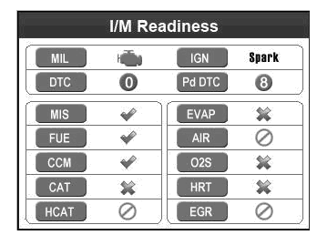

Figure 17
Note: You may need to complete
a Drive Cycle before performing an I/M Readiness Test if the battery has been disconnected or DTCs have been erased recently.

Icon Interpretations

MIL - “Check Engine” light status
IGN - Ignition type

DTC - Number of stored DTCs
PdDTC - Number of pending DTCs

Symbol Interpretations

Each Monitor’s readiness is indicated by one of the following symbols:

The Monitor has completed its diagnostic routine and is ready.

The Monitor has not completed its diagnostic routine and is not ready.
• Perform a Drive Cycle, then repeat the test.

The Monitor is not supported on the vehicle and may be deselected according to “Configure Monitors” on page 14.

Keyboard LED Interpretations

1. Green LED - Ready
Indicates that engine systems are running normally and no pending DTCs are present.
2. Yellow LED - Might be Ready Indicates there are pending DTCs or there are Monitors that have not finishing running.
• Perform a Drive Cycle, then repeat the test.

3. Red LED - Not Ready
Indicates there is a fault condition in one of the vehicle’s systems and stored DTCs are present.
• Have the vehicle serviced.

Diagnostic Test Modes

CAUTION: Do not connect or disconnect the Scan Tool while the ignition
is on or the engine is running.
1. Connect the Scan Tool. according to
“Connect Scan Tool” on page 12.

Access Diagnostic Menu

1. From the Main Menu, use the Up/ Down/ Left/ Right button to select OBDII/EOBD (Diagnostic Menu), then press OK.
2. Turn the vehicle’s ignition ON
with the engine OFF.
Note: Not all vehicles return the same data, results may vary from the examples given herein.

3. Control Module will display.
In Figure S below, the example vehicle uses the CAN Protocol and has the following Control Modules:
$7E8 - PCM ID
$7E9 - TCM ID
(See Control Modules on
page page 6 for more information.)

Control Module 1/2

Main Menu
2. System Status will display momentarily.

System Status
MIL Status OFF
Codes Found 2
Ignition Type Spark
Monitors N/A 4
Monitors OK 4
Monitors INC 2
$7E8
$7E9 ?

Figure 19
4. Press OK to go to Diagnostic Menu.

Diagnostic Menu 1/11

Figure 18
Read Codes Erase Codes

Live Data ? View Freeze Frame
I/M Readiness
02 Monitor Test*
On-Board Mon. Test

Figure 20

Note: If vehicle is 2008 or newer, the
02 Monitor Test* will not be present.

Read Trouble Codes
Modes $03, $07 and $0A Request Emission-Related DTCs

1. From Diagnostic Menu, use the Up/ Down button to select
Read Codes, then press OK.

Diagnostic Menu 1/11

Read Codes Erase Codes

Live Data ? View Freeze Frame
I/M Readiness
02 Monitor Test
On-Board Mon. Test

Figure 21

Read Codes

1. From Read Codes, select from:
a. Stored Codes - Mode $03
b. Pending Codes - Mode $07
c. Permanent Codes - Mode $0A This mode is available on
some vehicles starting in
2010 and is required on all
2012 and newer vehicles.
2. If there are no DTCs, the message “No codes are stored in the module” will appear.

3. View the DTC.

DTC Control Module

2/8
P0122 $10 Generic

Throttle / Pedal Position
Sensor / Switch A Circuit Low

DTC Description
Figure 22
4. See “DTC Lookup” on page 20
to view likely causes for DTCs.
Note: To view operational data stored when the DTC was stored, see
View Freeze Frame Data on page 28.

DTC Lookup

Search the DTC library for code definitions.
From the Main Menu, use the Up/ Down/ Left/ Right button to select DTC Lookup,
then press OK.
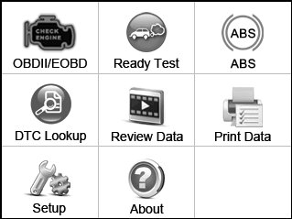

P0212

Injector Circuit/ Open Cylinder 12

1/1

Main Menu
1. Input the DTC by using the buttons to highlight and change digits, then press OK.
DTC Lookup
P0212
Left
Right
Change digit
OK Confirm
ESC Exit
Figure 24

2. Press the ? button to view likely causes for the DTC.
3. If a DTC is manufacturer specific, a screen will prompt the choice of vehicle make.
4. If a DTC is not found, the Scan Tool will refer you to the vehicle’s owner’s manual.
Note: DTC definitions can also be found online.

Figure 23

Erase Codes
Mode $04 Clear/Reset Emission-Related Diagnostic Information

WARNING! Do not clear any DTCs before the vehicle has been repaired and the system has been checked completely by
a qualified technician.
As long as there is a fault condition, the DTCs will continue to set and turn on the MIL.
Note: If the vehicle stores permanent DTCs, they cannot be erased by the Scan Tool. They can only be erased
by the OBD II system, after repairs are made, and a set number of Driving Cycles have been completed.
1. Turn the vehicle’s ignition ON
with the engine OFF.
2. From Diagnostic Menu, use the Up/ Down button to select Erase Codes,
then press OK.

Diagnostic Menu 2/11

Read Codes
Erase Codes Live Data ? View Freeze Frame
I/M Readiness
02 Monitor Test
On-Board Mon. Test

Figure 25

3. Choose whether or not to erase codes.

Erase Codes

Erase trouble codes!
Are you sure?

YES NO

Figure 26
4. When DTCs have been erased, the following message will appear.

Erase Codes Erase Done!
Press any key to con.

Figure 27
Note: Erasing codes will reset the Monitors to incomplete status. A Drive Cycle will
need to be completed before performing an Emissions Readiness Test.
Clearing the error code will not repair the car. Repair the car, then clear the error code.

View Live PID Data

This function allows viewing of one frame
of data only, for multiple frame viewing, see
“Record Live PID Data” on page 24.
This section contains advanced functions. Some of the data may need to be interpreted by a qualified technician.
1. From Diagnostic Menu, use the Up/ Down button to select Live Data,
then press OK.
Diagnostic Menu 3/11

Read Codes
Erase Codes
Live Data ? View Freeze Frame
I/M Readiness
02 Monitor Test
On-Board Mon. Test

Figure 28

2. From Live Data, use the Up/ Down button to select View Data, the press OK.

……………… .Live Data 1/3.

View Data
Record Data
Playback Data ?

Figure 29

Complete Data Set - View All PIDs

1. From View Data, use the Up/ Down button to select Complete Data Set,
then press OK.
…………………View Data 1/3.

Complete Data Set Custom Data Set
Unit of Measure ?

Figure 30
2. View all PIDs and their parameters using the Up and Down Buttons.

3. Press ? to view the PID’s full name.

……………… ..SHRTFT1 ……… …….

Short Term Fuel Trim Bank 1

4. Press OK to view a graph, if available.

RPM (/MIN) 975

1725

Live Data 6 DTC_CNT 0
FUELSYS1 0L FUELSYS2 -- ? LOAD_PCT (%) 0.0
ECT(°F) -40.0

925

Figure 32

SHRTFT1 (%) -0.0
LONGFT1 (%) -0.8

Figure 31
Note: If necessary, have a qualified technician interpret the data.

Custom Data Set - View Selected PIDs

1. From View Data, use the Up/ Down button to select Custom Data Set,
then press OK.

…………………View Data 2/3.

3. Select PIDs to view.

……..Custom Data Set 4/20

Complete Data Set
Custom Data Set
Unit of Measure ?

Figure 33
2. Custom Data Set screen shows which buttons can be used to select/deselect PIDs. Press any button to move to the next screen.
√ DTC_CNT
FUELSYS1
FUELSYS2 ?
LOAD_PCT #001
ECT SHRTFT1
LONGFTI

Figure 35
4. Press OK to view selected PIDs.
……….Live Data 1 . DTC_CNT 0

……………Custom Data Set……… …..

[ ] – Select/Deselect
[ ] – Select/Deselect all
[OK] – Confirm
[ESC] – Cancel

Press any key to con.

Figure 34

?

Figure 36
Note: If necessary, have a qualified technician Interpret the data.

Record Live PID Data

View multiple frames of data collected over a period of time.
This section contains advanced functions. Some data may need to be interpreted by a qualified technician.
1. From Diagnostic Menu, select
Live Data, then press OK.

2. From Live Data, use the Up/ Down button to select Record Data, the press OK.

……………… .Live Data 2/3. View Data
Record Data Playback Data ?

Diagnostic Menu 3/11

Read Codes
Erase Codes
Live Data ? View Freeze Frame
I/M Readiness
02 Monitor Test
On-Board Mon. Test

Figure 37

Figure 38

Complete Data Set - Record All PIDs

WARNING! DO NOT attempt to operate the Scan Tool while driving the vehicle. Have a passenger operate the Scan Tool.
1. Start the vehicle and begin driving.
2. From Record Data, have the passenger select Complete Data Set, then press OK.
………………..Record Data 1/3..

Complete Data Set
Custom Data Set
Unit of Measure ?

Figure 39

3. Have the passenger select a Trigger Mode:
• Manual Trigger - Recording will begin after memory location is selected.
• DTC Trigger - Recording will begin when a DTC is detected.

…….……Pick Trigger Mode 1/2

Manual Trigger DTC Trigger ?

Figure 40

Complete Data Set - Record All PIDs (continued)

3. From Select Memory, have
the passenger select a memory location, then press OK.

…………….Select Memory 1/3..

Location #1 * Location #2
Location #3 ?

Figure 41
Note: An asterisk (*) next to a
location indicates a recording already exists there. Selecting this location will overwrite it with new data.

4. After the passenger determines that recording is finished, stop driving. Data can be viewed immediately or saved to view later.

Record Data

Recording Done! Playback data?

YES NO

Figure 42

Playback Data

Note: If necessary, have a qualified technician interpret the data.
1. Scroll Left/Right/Up/Down to view Playback Data:

Frame 6 of 46 in Row 36
…P…la. yback 6/46 Frame 36 .. DTC_CNT 0
FUELSYS1 0L
FUELSYS2 -- ? LOAD_PCT(%) 0.0

Interpret Playback Data:
In the grid below, each row contains frames of PID values shown in Figure AQ.
In this example, there are 36 PIDs (rows)
with 46 frames in each row.
The highlighted frame shows frame
6 of 46 for Row 36. This particular frame shows that the PID for Short Term Fuel Trim Bank 1 has a value of 99.2%.
Each frame shows a value at the time of capture, making it possible

Row
36
ECT(° F) -40
SHRTFT1(%) 99.2

Figure 43
to see how the values of individual
PIDs fluctuate over the course of the recording by scrolling across rows.

3/46
34
3/46
35
3/46
36
4/46
34
4/46
35
4/46
36
5/46
34
5/46
35
5/46
36
Frame 6/46
Row 34 - LOAD PCT(%) 0.0
Frame 6/46
Row 35 - ECT(° F) - 40
Frame 6/46
Row 36 - SHRTFT1(%) 99.2
7/46
34
7/46
35
7/46
36
8/46
34
8/46
35
8/46
36
9/46
34
9/46
35
9/46
36

Figure 44: Interpreting Playback Data

Custom Data Set - Record Select PIDs

WARNING! DO NOT attempt to operate the Scan Tool while driving the vehicle. Have a passenger operate the Scan Tool.
1. Start the vehicle and begin driving.
2. From Record Data, have the passenger select Custom Data Set, then press OK.
………………..Record Data 2/3.. Complete Data Set
Custom Data Set Unit of Measure ?

Figure 45
3. Custom Data Set screen shows which buttons can be used to select/deselect PIDs. Have the passenger press any button to move to the next screen.

……………Custom Data Set……… …..

[ ] – Select/Deselect
[ ] – Select/Deselect all
[OK] – Confirm
[ESC] – Cancel

Press any key to con.

Figure 46
4. Have the passenger select/deselect PIDs.

5. Have the passenger select a Trigger Mode:
• Manual Trigger - Recording will begin after memory location is selected.
• DTC Trigger - Recording will begin when a DTC is detected.

…….……Pick Trigger Mode 1/2

Manual Trigger DTC Trigger ?

Figure 48
6. From Select Memory, have
the passenger select a memory location, then press OK.

…………….Select Memory 1/3..

Location #1 * Location #2
Location #3 ?

Figure 49 Note: An asterisk (*) next to a
location indicates a recording already exists there. Selecting this location will overwrite it with new data.

……..Custom Data Set 4/20

√ DTC_CNT FUELSYS1
FUELSYS2 ?
LOAD_PCT #001
ECT SHRTFT1
LONGFTI

Figure 47

Custom Data Set - Record Select PIDs (continued)

7. After the passenger determines that recording is finished, stop driving. Data can be viewed immediately or saved to view later.

8. Interpret data according to
“Playback Data” on page 25.
Note: If necessary, have a qualified technician interpret the data.

Record Data

Recording Done! Playback data?

YES NO

Figure 50

Playback Live PID Data

This section contains advanced functions. Some data may need to be interpreted by a qualified technician.
1. From Diagnostic Menu, use the Up/ Down button to select Live Data,
then press OK.

Diagnostic Menu 3/11

Read Codes
Erase Codes
Live Data ? View Freeze Frame
I/M Readiness
02 Monitor Test
On-Board Mon. Test

Figure 51
2. From Live Data, use the Up/ Down button to select Playback Data,
then press OK.

……………… .Live Data 3/3. View Data
Record Data
Playback Data ?

Figure 52
3. From Select Memory, use the Up/ Down button to select a memory location marked with an asterisk (*), then press OK.
…………….Select Memory 1/3..

Location #1 * Location #2
Location #3 ?

Figure 53
4. Interpret data according to
“Playback Data” on page 25.
Note: If necessary, have a qualified technician Interpret the data.

View Freeze Frame Data
Mode $02 Request Powertrain Freeze Frame Data

View the vehicle’s operating conditions when a DTC is stored.
This section contains advanced functions. Some data may need to be interpreted by a qualified technician.
Note: Not all vehicles return the same data, results may vary from the examples given herein.
1. From Diagnostic Menu, use the Up/ Down button to select View Freeze
Frame, then press OK.
Diagnostic Menu 4/11

2. View data.
…………View Freeze Frame 2 . DTCFRZF P1633
FUELSYS1 OL FUELSYS2 -- LOAD_PCT (%) 0.0 ? ECT(° F) -40
SHRTFT1 (%) 99.2

Figure 55
3. Select a PID, then press OK
to view the full name.

Read Codes
Erase Codes
Live Data ? View Freeze Frame I/M Readiness
02 Monitor Test
On-Board Mon. Test

Figure 54

I/M Readiness

Check emissions readiness prior to having a vehicle inspected for a state Emissions Test.
1. From Diagnostic Menu, use the Up/ Down button to select I/M Readiness,
then press OK.

……………… ..FUELSYS1……… …….

Fuel System 1 Status

Figure 56
Note: If necessary, have a qualified technician Interpret the data.

2. View test results.

Diagnostic Menu 5/11
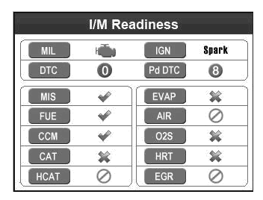

Read Codes
Erase Codes
Live Data ? View Freeze Frame

I/M Readiness
02 Monitor Test
On-Board Mon. Test

Figure 57

Figure 58
Note: See “I/M Readiness Quick- Check” on page 17 to interpret data.

02 Monitor Test
Mode $05 Request Oxygen Sensor Monitoring Test Results
(2007 and older vehicles only)

View the oxygen sensor test data on pre-CAN vehicles.
For CAN vehicles, see On-Board
Monitor Test on page 30.
This section contains advanced functions. Some data may need to be interpreted by a qualified technician.
Note: Not all vehicles return the same data, results may vary from the examples given herein.
1. From Diagnostic Menu, select
O2 Monitor Test, then press OK.

Diagnostic Menu 6/11

Read Codes
Erase Codes
Live Data ? View Freeze Frame
I/M Readiness

2. Select a sensor, then press OK.

............O2 Monitor Test 2/2

O2 Bank1 Sensor1
O2 Bank1 Sensor2
?

Figure 60
3. View data.

O2 Bank1 Sensor2 1/4. Rich- Lean Threshd V
Lean-Rich Threshd V
Min for text Cyc (V) ? Max for text Cyc (V)

02 Monitor Test On-Board Mon. Test

Figure 59
Figure 61
Note: If necessary, have a qualified technician Interpret the data.

On-Board Monitor Test
Mode $06 Request On-Board Monitoring Test
Results for Specific Monitored Systems

View test data for Non Continuous Monitors.
This section contains advanced functions. Some data may need to be interpreted by a qualified technician.
Note: Not all vehicles return the same data, results may vary from the examples given herein.
1. From Diagnostic Menu, use the Up/ Down button to select On-Board
Mon. Test, then press OK.
Diagnostic Menu 7/11

Read Codes
Erase Codes
Live Data ? View Freeze Frame
I/M Readiness
02 Monitor Test
On-Board Mon. Test

Figure 62

2. Select vehicle manufacturer.

Vehicle Manufacturer 1/28

BUICK BMW
CADILLAC ? CHEVROLET
CHRYSLER FORD

Figure 63
3. Select and view Monitors, their tests and results as needed.
On-Board Mon. Test 1/10
A/F Sensor Bank Sensor 1
H02S Bank Sensor 2
Catalyst Mon. Bank 1 ?
EVAP
EGR Heater Mon.B1S2
Misfire
Misfire

Figure 64
Note: If necessary, have a qualified technician Interpret the data.

Component Test
Mode $08 - Request Control of On-Board
System, Test or Component

Command the PCM to run an Evaporative Leak Test.
This section contains advanced functions. Some data may need to be interpreted by a qualified technician.
Note: Not all vehicles return the same data, results may vary from the examples given herein.
1. From Diagnostic Menu, use the Up/ Down button to select Component
Test, then press OK.
Diagnostic Menu 8/11

If the vehicle responds, a confirmation message will be displayed.
Component Test
Command Sent! Press any key to con.

Figure 67
2. View test module.

Component Test Vehicle Info.
Modules Present
Unit of Measure

Figure 65
If the vehicle does not allow the test, an advisory message will be displayed.

EVAP Monitor(0.090) 1/1

$81 Test

Figure 68
3. Press OK for test results.

.............Component Test

The selected mode is not supported

Press any key to con.

Figure 66
$81 Test TEST 00:00:18
MIN 00:00:00
MAX 00:01:05
STS OK

Figure 69
Note: If necessary, have a qualified technician Interpret the data.

Mode $09 Vehicle Information

View vehicle information, such as
VIN, Calibration ID, and CVN.
Note: Not all vehicles return the same data, results may vary from the examples given herein.
1. From Diagnostic Menu, use the Up/ Down button to select Vehicle Info.,
then press OK.
Diagnostic Menu 9/11

Component Test
Vehicle Info. Modules Present
Unit of Measure

Figure 70
2. From Vehicle Info., use the Up/ Down button to select Vehicle ID Number,
then press OK.
Vehicle Info. 1/3

Vehicle ID Number Calibration ID
Cal. Verf. Number

Figure 71
3. View Vehicle ID Number.
Vehicle ID Number

VIN: LSVGU49JX92545482

Figure 72
4. From Vehicle Info., use the Up/ Down button to select Calibration ID,
then press OK.

Vehicle Info. 2/3

Vehicle ID Number
Calibration ID
Cal. Verf. Number

Figure 73
5. View Calibration ID information.
Calibration ID

Cal ID: 03C906057DD 3886

Figure 74
6. From Vehicle Info., use the Up/ Down button to select Cal. Verf. Number,
then press OK.
Vehicle Info. 3/3 Vehicle ID Number
Calibration ID
Cal. Verf. Number

Figure 75
7. View CVN information.

Cal. Verf. Number CVN1: 2B 9B F5 E4

Figure 76

Modules Present

View Control Module IDs and their
Communication Protocols.
Note: Not all Modules are supported by all vehicles.
Note: Not all vehicles return the

2. Control Module will display.
3. In Figure BZ below, the example vehicle uses a CAN bus and has the following ODB Control Module IDs and Protocols:

same data, results may vary from
ID Control
Module
Communication
Protocol

the examples given herein.
1. From Diagnostic Menu, use the Up/ Down button to select Modules
Present, then press OK.
$7E8 Powertrain CAN bus
$7E9 Transmission CAN bus

Diagnostic Menu 10/11

Modules Present 1/3

Component Test
Vehicle Info.
Modules Present Unit of Measure

Figure 77

ID
$7E8
$7E9
Protocol CAN STD FAST CAN STD FAST

Figure 78

ABS+SRS Testing

From the Main Menu, select ABS, then press OK.

Main Menu
Vehicle Area will display, select your vehicle area.
Vehicle area 1/3

1. USA
2. EUROPEAN
3. ASIAN ?

Figure 79
For example: To run ABS test on GM:
- Select USA and wait for the Vehicle Type to appear.
2. Select GM from the Vehicle Type menu.
Vehicle Type 5/5
1. CHRYSLER
2. DODGE
3. FORD ?
4. LINCOLN
5. GM

Figure 80
3. Select Manual Select from the Please select text way menu.
Please select test way 2/2
1. Auto Identify
2. Manual Select
?
Figure 81

Note: If you select the Auto Identify, the tool will directly turn to the Diagnostic Menu.
4. Choose the correct Model Year.
The 10th VIN Char. 5/18
1.［D］2013
2.［C］2012
3.［B］2011 ?
4.［A］2010
5.［9］2009
6.［8］2008
7.［7］2007
Figure 82
5. Select your vehicle type.
Vehicle Type. 1/3
1.Passenger Car
2. LD, Trk MPV, incomplete
3. Medium Duty Truck ?

Figure 83
6. Choose your vehicle manufacturer.
Vehicle Manufacturer 1/6
1. Buick
2. Chevrolet
3. Pontiao ?
4. Cadillac
5. Saturn
6. Holden
Figure 84
7. Choose the system you expect to test..
System 1/2
1. ABS
2. SRS
?

Figure 85

Then the Diagnostic Menu will display.
Review Data - Mode $01 - Current Powertrain Diagnostic Data

View data from the last recorded test.
Note: Not all vehicles return the same data, results may vary from the examples given herein.
From the Main Menu, use the Up/ Down/ Left/ Right button to select
Review Data, then press OK.
1. Select and view data as needed.

Review Data 1/3

Live Data I/M Readiness
Modules Present

Figure 86
Note: If necessary, have a qualified technician Interpret the data.

Main Menu

Ready Test

CAUTION: Do not connect or disconnect the Scan Tool while the ignition
is on or the engine is running.
1. Connect the Scan Tool according to
“Connect Scan Tool” on page 12.
2. Turn the vehicle’s ignition ON
with the engine OFF.
3. From the Main Menu, use the Up/ Down Left/ Right button to select Ready Test,
then press OK.
4. View test results.

Figure 87

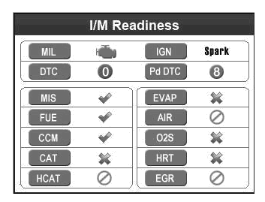

Note: See “I/M Readiness Quick- Check” on page 17 to interpret data.

Main Menu

Print Data

1. Connect the Scan Tool to the computer with the supplied USB Cable.
2. From the Main Menu, use the Up/ Down/ Left/ Right button to select
Print Data, then press OK.

Print Data 1/9

Stored Codes
Pending Codes
Live Data ? Freeze Frame
I/M Readiness O2 Sensor Test Print All Data

Figure 88
3. Follow instructions on the
Scan Tool and the computer.

Main Menu

Install/Update Software

This function allows you to update the Scan Tool software and DTC library through a computer.
Note: The Scan Tool comes with the most recent software and DTC library versions.
1. On the computer, install
setup.exe driver from the included CD
or download the driver from the internet:
- Go to www.kzyee.com
b. Search for KC501
c. Click Software Update tab
d. Download software
(if there is an update available) e. Open Update Instructions PDF f. Follow instructions

2. Connect the Scan Tool to the computer with the supplied USB Cable.
3. From System Setup, use the Up/ Down button to select Update Mode, then
press OK.

System Setup 7/7

Language
Configure Monitors ? Unit of Measure
Key Beep Set Status Beep Set Tool Self-test
Update Mode

Figure 89
4. Follow instructions on the
Scan Tool and the computer.

About

View software, hardware, and DTC library versions and Serial Number.
From the Main Menu, use the Up/ Down/ Left/ Right button to select About, then
press OK.

S/W Ver:v9.00
H/W Ver:V4.10
Serial No:
Burn Date:
LIB Ver:V4.90

Figure 90

Main Menu

NOTE: This equipment has been tested and found to comply with the limits for a Class B digital device, pursuant to part 15 of the FCC Rules. These limits are designed to provide reasonable protection against harmful interference in a residential installation. This equipment generates, uses and can radiate radio frequency energy and, if not installed and used in accordance with the instructions, may cause harmful interference
to radio communications. However, there is no guarantee that interference will not occur in a particular installation. If this equipment does cause harmful interference to radio or television reception, which can be determined by turning the equipment off and on, the user is encouraged to try to correct the interference by one or more of the following measures:
-Reorient or relocate the receiving antenna.
-Increase the separation between the equipment and receiver.
-Connect the equipment into an outlet on a circuit different from that to which the receiver is connected.
-Consult the dealer or an experienced radio/TV technician for help.

Inspection and Maintenance

Procedures not specifically explained in this manual must be performed only by a qualified technician.

TO PREVENT SERIOUS INJURY FROM ELECTRICAL SHOCK: Make sure that the Scan Tool is unplugged from the vehicle before performing any procedure in this section.

TO PREVENT SERIOUS INJURY FROM TOOL FAILURE:
Do not use damaged equipment. If abnormal noise or vibration occurs, have the problem corrected before further use.

Inspection

1. BEFORE EACH USE, inspect the general condition of the Scan Tool. Check for:

Cleaning and Storage

1. AFTER USE, use a mild detergent on a clean cloth to remove any oil, grease or dirt from the Scan Tool, especially on the buttons, being careful to not put excessive pressure on the Display Screen.

• cracked or damaged Cable,
• cracked or broken parts, and
• any other condition that may affect its safe operation.

2. Do not use solvents on the Keyboard.
Do not soak the Keyboard, Use a mild nonabrasive detergent and a soft cloth.
3. Store the Scan Tool, and accessories away from sunlight in a dry, locked area, out of the reach of children.

Troubleshooting

Problem Possible Causes Likely Solutions

Scan Tool doesn’t power up 1. OBD II Cable connector not connected securely.

2. Vehicle’s DLC pins are bent or broken.
3. Vehicle’s battery is bad. Vehicle Linking Error 1. Vehicle is not OBD
compliant.
2. Ignition is off.
3. Bad connection.

Scan Tool Freezes Scan Tool or vehicle’s computer system
not responding.
1. Verify that the Scan Tool’s OBD II Cable connector is securely connected to the vehicle’s DLC.
2. Check if the DLC pins are bent or broken. If bent or broken, have a certified technician repair the DLC.
3. Make sure vehicle’s battery it providing at least 8V.
1. Verify that the vehicle is
OBD II compliant.
2. Verify that the ignition is ON.
3. Reset the tool by turning the ignition off, waiting 10 seconds, then turning the ignition back on.
Reset the Scan Tool by turning the ignition off, waiting 10 seconds, then turning the ignition back on.

LED Lamps Not Working Defective LEDs Run the LED Test, according to page16. If LED(s) fail, have a
qualified technician replace the LED(s).

Follow all safety precautions whenever diagnosing or servicing the tool. Disconnect power supply before service.

PLEASE READ THE FOLLOWING CAREFULLY

THE MANUFACTURER AND/OR DISTRIBUTOR HAS PROVIDED THE PARTS LIST IN THIS DOCUMENT AS A REFERENCE TOOL ONLY. NEITHER THE MANUFACTURER OR DISTRIBUTOR MAKES ANY REPRESENTATION OR WARRANTY OF ANY KIND TO THE BUYER THAT HE OR SHE IS QUALIFIED TO MAKE ANY REPAIRS TO THE PRODUCT, OR THAT HE OR SHE IS QUALIFIED TO REPLACE ANY PARTS OF THE PRODUCT. IN FACT, THE MANUFACTURER AND/OR DISTRIBUTOR EXPRESSLY
STATES THAT ALL REPAIRS AND PARTS REPLACEMENTS SHOULD BE UNDERTAKEN BY CERTIFIED AND LICENSED TECHNICIANS, AND NOT BY THE BUYER. THE
BUYER ASSUMES ALL RISK AND LIABILITY ARISING OUT OF HIS OR HER REPAIRS TO THE ORIGINAL PRODUCT OR REPLACEMENT PARTS THERETO, OR ARISING OUT OF HIS OR HER INSTALLATION OF REPLACEMENT PARTS THERETO.

Parts List
Part Description Qty
1 Scan Tool 1
2 OBD II Cable 1
3 USB Cable 1
4 Storage Bag 1

Record Serial Number Here:

Note: If product has no serial number, record month and year of purchase instead.
Note: Some parts are listed and shown for illustration purposes only, and are not available individually as replacement parts.
Limited 90 Day Warranty

KZYEE makes every effort to assure that its products meet high quality and durability standards, and warrants to the original purchaser that this product is free from defects in materials and workmanship for the period of 90 days from the date of purchase. This warranty does not apply to damage due directly or indirectly, to misuse, abuse, negligence or accidents, repairs or alterations outside our facilities, criminal activity, improper installation, normal wear and tear, or to lack of maintenance. We shall in no event be liable for death, injuries to persons or property, or for incidental, contingent, special or consequential damages arising from the use of our product. Some states do not allow the exclusion or limitation of incidental or consequential damages, so the above limitation of exclusion may not apply to you. THIS WARRANTY IS EXPRESSLY IN LIEU OF ALL OTHER WARRANTIES, EXPRESS OR IMPLIED, INCLUDING THE WARRANTIES OF MERCHANTABILITY AND FITNESS.

To take advantage of this warranty, the product or part must be returned to us with transportation charges prepaid. Proof of purchase date and an explanation of the complaint must accompany the merchandise. If our inspection verifies the defect, we will either repair or replace the product at our election or we may elect to refund the purchase price if we cannot readily and quickly provide you with a replacement. We will return repaired products at our expense, but if we determine there is no defect, or that the defect resulted from causes not within the scope of our warranty, then you must bear the cost of returning the product.

This warranty gives you specific legal rights and you may also have other rights which vary from state to state.

